**L3 Title:** Add Provider to all Billing Groups.

1. First we have to check the bill structure is new or old from PMPRXFT.
2. If its bit is 0 its old, and new If bit is 1.
3. Get provider id from PMPRVFT table using provider name.
4. Get total billing entities from GroupsInfo Table where VTYPE is billing.
5. Get total group provider entities from GroupProviderList that matches with given provider id.
6. Insert the given provider in all the groups.

**Query:**

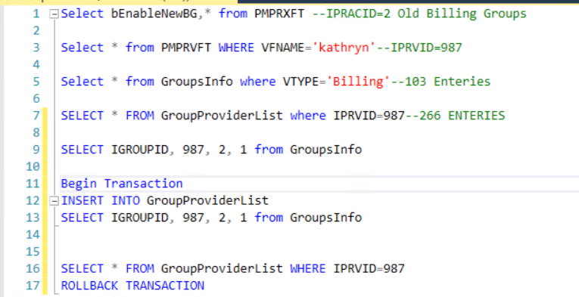

Table’s information:

|  |  |
| --- | --- |
| PMPRXFT | Practice table |
| PMPRVFT | Providers table |
| GroupsInfo | Providers group |
| GroupsProviderList | ProviderGroups list |

Coolum’s information:

|  |  |
| --- | --- |
| VFNAME | Provider first name |
| VTYPE | Billing |
| IPRVID | Provider id |
| bEnableNewBG | Bit column for checking new or old billing group |